Given the head of a singly linked list, reverse the list, and return *the reversed list*.

**Example 1:**

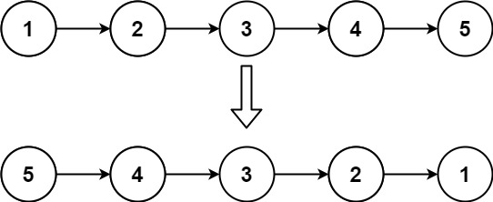

Input: head = [1,2,3,4,5]  
Output: [5,4,3,2,1]

**Example 2:**

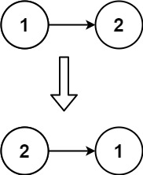

Input: head = [1,2]  
Output: [2,1]

**Example 3:**

Input: head = []  
Output: []

**Constraints:**

* The number of nodes in the list is the range [0, 5000].
* -5000 <= Node.val <= 5000

**Follow up:** A linked list can be reversed either iteratively or recursively. Could you implement both?